**Status Summary:**

During this project I’ve taken the approach of going from low level language(Verilog) to high level language(Python) and try to see the differences in runtime and space complexities of each one. Below the text the block diagram can be found, which is specifying the current status of each component of the project. After some search through the internet I’ve found a couple of translators for high level languages that worth testing (both for C and Python languages, can be found below as well). The Verilog SVM algorithm was problematic to find, I’ve encountered difficulties locating this specific algorithm as every public source is translated from C or Python codes. Another step I’ve taken was to look for other ML algorithms including linear/logistic regression, Perceptron, KNN and neural networks. After meeting with professor Kim we have thought on two possible alternatives which I’m going to try until the next update:

* Programing one of the algorithms in Verilog
* Try and broaden the domain into other regions besides ML.

**Python translators:**

<http://www.myhdl.org/>

<https://github.com/UCSBarchlab/PyRTL>

<https://web.csl.cornell.edu/pymtl2015/>

<http://www.pynq.io/>

<https://github.com/evlog/SysPy>

<https://www.eetimes.com/document.asp?doc_id=1329857>

**C translators:**

<http://www.cl.cam.ac.uk/~djg11/ctovpages/>

<https://www.xilinx.com/products/design-tools/vivado/integration/esl-design.html>

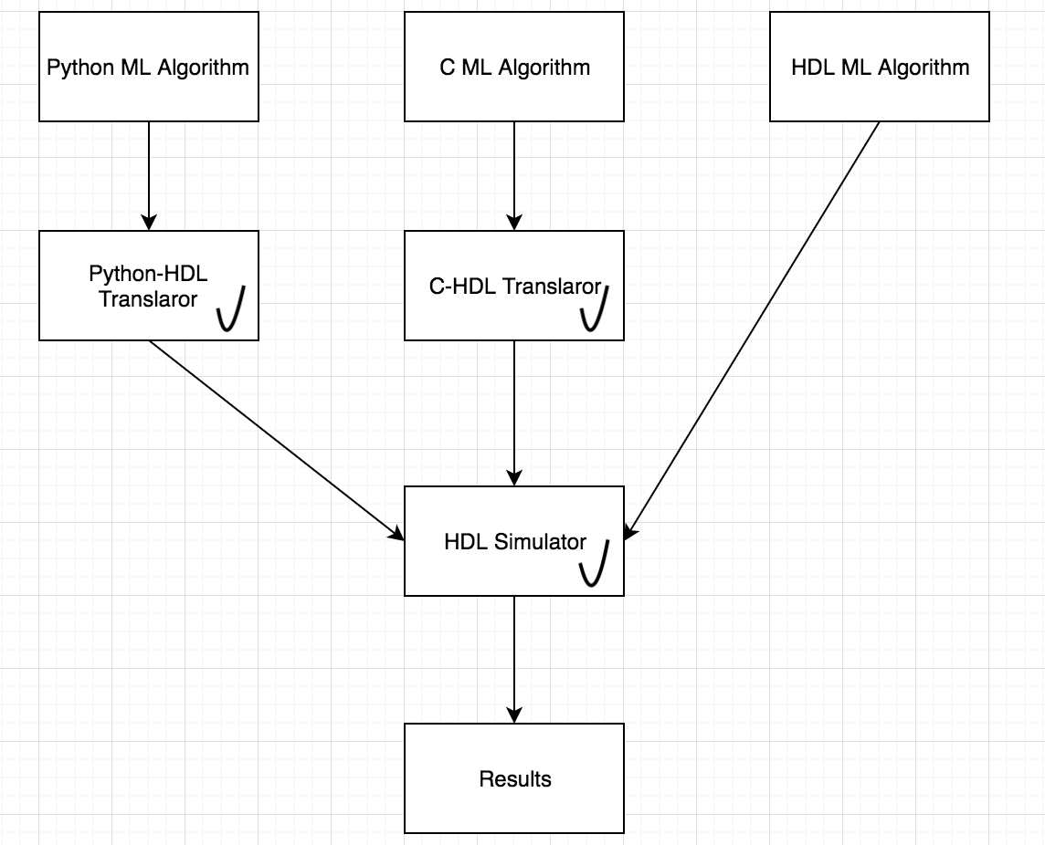**Project’s Block Diagram:**